Critique and Feedback
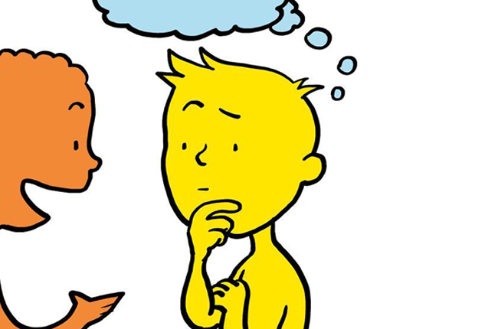
- Give advice
- Be Honest
- Be Specific
- Be kind & thoughtful

- Listen
- Try again/improve
- Persevere

